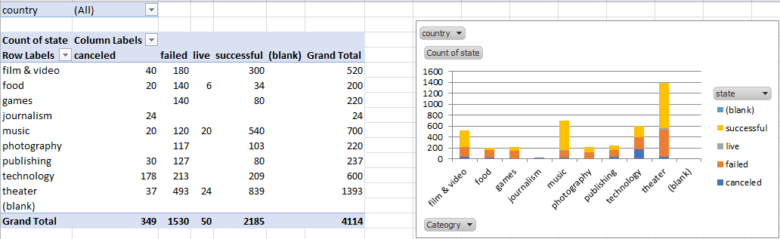

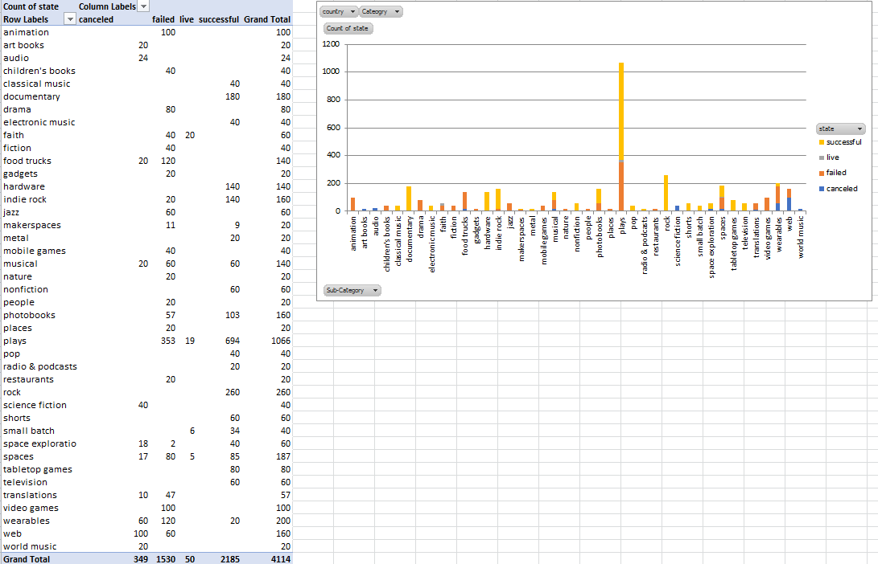

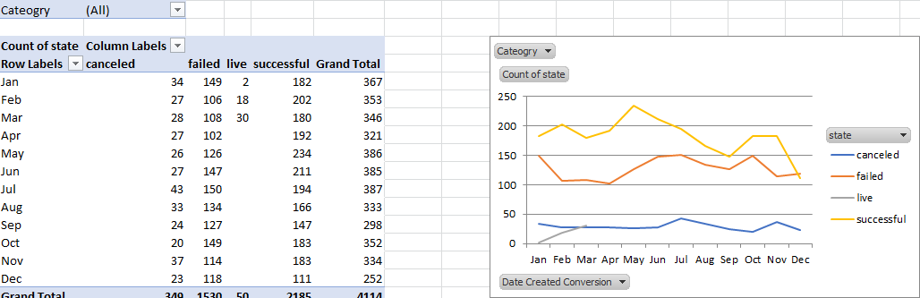

Theater has the most number of kickstarter campaigns and journalism has the lowest. Within the Theater category Plays sub-category had the most number of kickstarter campaigns. The number of kickstarter campaigns launched in December seems to be lower compared to any other month.

The dataset only shows nominal value and does not show any comparison metrics like the percentage of successful kick starters by category.

We can create a table that can show the state percentage by category.

